This section examines the size reduction effect by the integrated transformer. For this study, the conventional transformer is assumed to be two separate transformers that facilitate isolation between the primary and secondary side. A representation is shown in Fig. 12(a), and its windings are represented in Fig. 13(a). The proposed integrated transformer is represented in Fig. 12(b) and its windings are represented in Fig. 13(b). The volume is compared by using the area product (AP) method, and insights on winding and core loss are also given.
- Area Product Calculation
The AP method utilizes the product between the core cross-sectional area, $A_{c}$, and the window area, $A_{w}$, and is a fundamental core size for the application. It can be expressed both in terms of the transformer geometric parameters and the circuit parameters, as will be demonstrated in the following analysis.
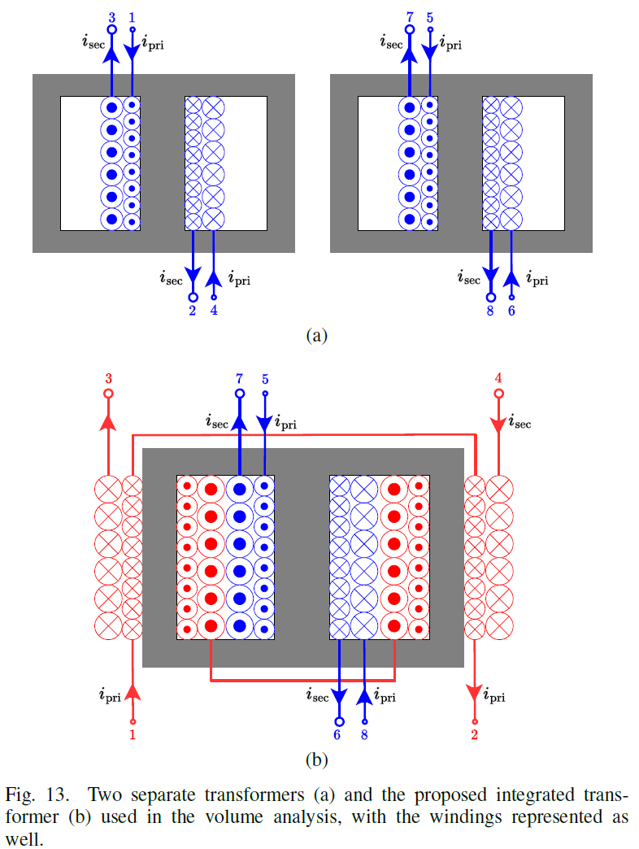
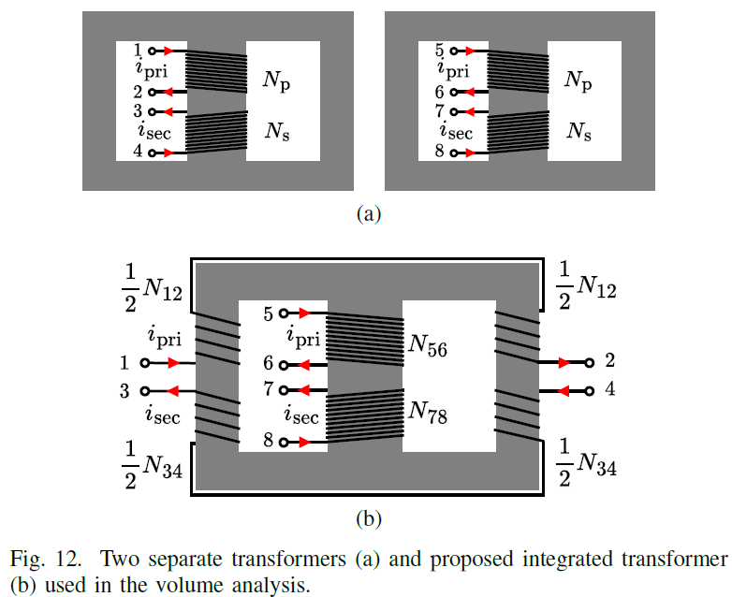
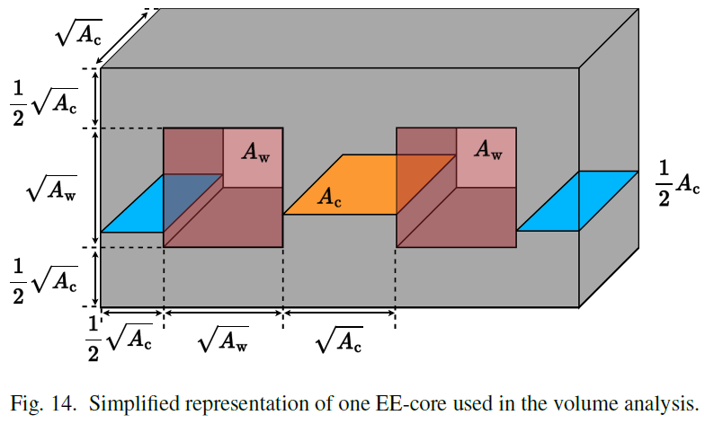

The EE-core was redesigned in such a way such that $A_{w}$ and $A_{c}$ are squares to allow for simpler analysis, as shown in Fig. 14. Here, $A_{c}$ is twice the area of the outer leg.
For the conventional transformer, $A_{c}$ is expressed in (29). Here, $N_{p}$ is the number of turns wound on the center leg of the conventional transformer.
$$A_{c_{conv}}=\frac{L_{m}I_{pri_{pk}}}{B_{max}N_{p}} \left(29\right)$$
For the integrated transformer, $A_{c}$ is expressed in (30).
$$A_{c_{integ}}=\frac{L_{m}I_{pri_{pk}}}{B_{max}N_{56}} \left(30\right)$$
The window area $A_{w}$ can be expressed in terms of winding area and the occupancy ratio $K_{u}$, as (31) for the conventional transformer:
$$A_{w_{conv}}K_{u}=N_{p}\frac{I_{pri_{rms}}}{J_{m}}+N_{s}\frac{I_{sec_{rms}}}{J_{m}} \left(31\right)$$
which simplifies to:
$$A_{w_{conv}}=\frac{N_{p}}{J_{m}K_{u}}\left(I_{pri_{rms}}+\frac{I_{sec_{rms}}}{n}\right) \left(32\right)$$
For the integrated transformer, winding $N_{12}$ and $N_{34}$ on the outer legs implies that $N_{12}≈2N_{56}$ and $N_{34}≈2N_{78}$. Taking into account that the core window has half the total turns of the transformer $N_{12}-N_{34}$, $A_{w}$ can be expressed as (33):
$$A_{w_{integ}}K_{u}=\left(N_{56}\frac{I_{pri_{rms}}}{J_{m}}+N_{78}\frac{I_{sec_{rms}}}{J_{m}}\right)+\frac{1}{2}\left(N_{12}\frac{I_{pri_{rms}}}{J_{m}}+N_{34}\frac{I_{sec_{rms}}}{J_{m}}\right) \\ =2\left(N_{56}\frac{I_{pri_{rms}}}{J_{m}}+N_{78}\frac{I_{sec_{rms}}}{J_{m}}\right)\left(33\right)$$
Using (29), (30), (32), and (33), the area product of the conventional and proposed integrated transformers are expressed in (34) and (35) respectively:
$$AP_{prop}=A_{c_{prop}}A_{w_{prop}}=\frac{L_{m}I_{p,pk}\left(I_{p,rms}+\frac{I_{s,rms}}{n}\right)}{B_{m}J_{m}K_{u}} \left(34\right)$$
$$AP_{integ}=A_{c_{integ}}A_{w_{integ}}=\frac{2L_{m}I_{p,pk}\left(I_{p,rms}+\frac{I_{s,rms}}{n}\right)}{B_{m}J_{m}K_{u}} \left(35\right)$$
From (34) and (35), $AP_{integ}≈2AP_{conv}$ ideally.
The total volume of the EE core in Fig. 14 is expressed in (36), where $x$ is a constant that denotes $A_{c}/A_{w}$.
The volume corresponding to the conventional and integrated transformer is obtained using their respective $A_{c}$ and $A_{w}$. Since the $A_{c}$ and $A_{w}$ depend on the number of corresponding turns, then the estimated volume will change depending on the actual implementation of the transformer.
$$Vol=2AP^{\frac{3}{4}}\left(2x^{\frac{1}{4}}+x^{\frac{3}{4}}+x^{-\frac{1}{4}}\right) (36)$$
The rms expressions of the primary and secondary side current of the interleaved flyback rectifier are given in (37) and (38).
$$I_{pri_{rms}}=\frac{V_{in_{max}}}{L_{m}f_{s}}\sqrt{\frac{D^{3}}{6}} (37)$$
$$I_{sec_{rms}}=\frac{V_{in_{max}}}{L_{m}f_{s}}\sqrt{\frac{4nD^{3}}{9π}⋅\frac{V_{in_{max}}}{V_{o}}} \left(38\right)$$
The AP calculation based on circuit specifications is summarized in Table III. It is important to note that the conventional transformer implementation comprises of two discrete cores, which therefore means the values indicated in this table is for one core only.
Table III
Volume analysis of the conventional and proposed transformer using the chosen core OP44721EC.
Item | Symbol | Conventional (1 core) | Proposed
Maximum Input Voltage | V_{in, max} | 240 V V_{rms}
Output Voltage | V_{O} | 48 V
Maximum Duty Cycle | D | 0.47
Switching Frequency | f_{s} | 100 kHz
Mag. Inductance | L_{m} | 82.8 $μ$H
Turn ratio | n | 3
Primary side pk. current | I_{p, pk} | 8.02 A
Primary side RMS current | I_{p, rms} | 5.39 A
Secondary side RMS current | I_{s, rms} | 12.53 A
Maximum flux density | B_{max} | 0.3 T
Maximum current density | J_{max} | 5 A/mm²
Occupancy ratio | K_{u} | 0.3
Area Product | AP | 14128.75 mm⁴ | 28257.50 mm⁴

The theoretical volume is dominated by the $AP^{3/4}$ scaling law as seen in (36), and thus the term $\left(2x^{\frac{1}{4}}+x^{\frac{3}{4}}+x^{-\frac{1}{4}}\right)$ can be treated as constant. Using the relationship $AP_{integ}≈2AP_{conv}$, then the amount of volume reduction can be computed using (36), with the reduction amounting to 16%$.$ This assumes that the integrated core geometry is custom-tailored to the specific AP requirements derived from the circuit specifications, rather than being constrained by standard core-shapes. While the experimental prototype described in Section V utilizes a commercial core (Magnetics 0P44721EC) for proof-of-concept, this theoretical analysis confirms that a purpose-built integrated core would offer significant improvements in power density compared to the conventional discrete implementation by standard commercial core shapes.
- Winding and Core Loss Comparison
Following the discussion in the last section, the $A_{c}$ and $A_{w}$ can be expressed in terms of the $AP$ and $x$ as shown in (39) and (40)
$$A_{c}=\sqrt{x⋅AP} \left(39\right)$$
$$A_{w}=\sqrt{\frac{AP}{x}} \left(40\right)$$
Assuming that $x=1$ and from the values in Table III, the core dimensions of the conventional and integrated transformer can be obtained.

